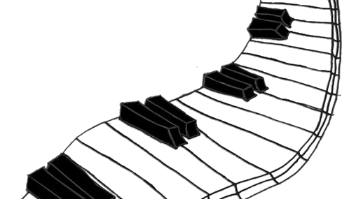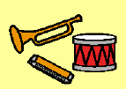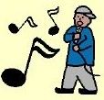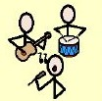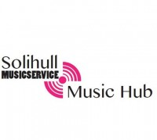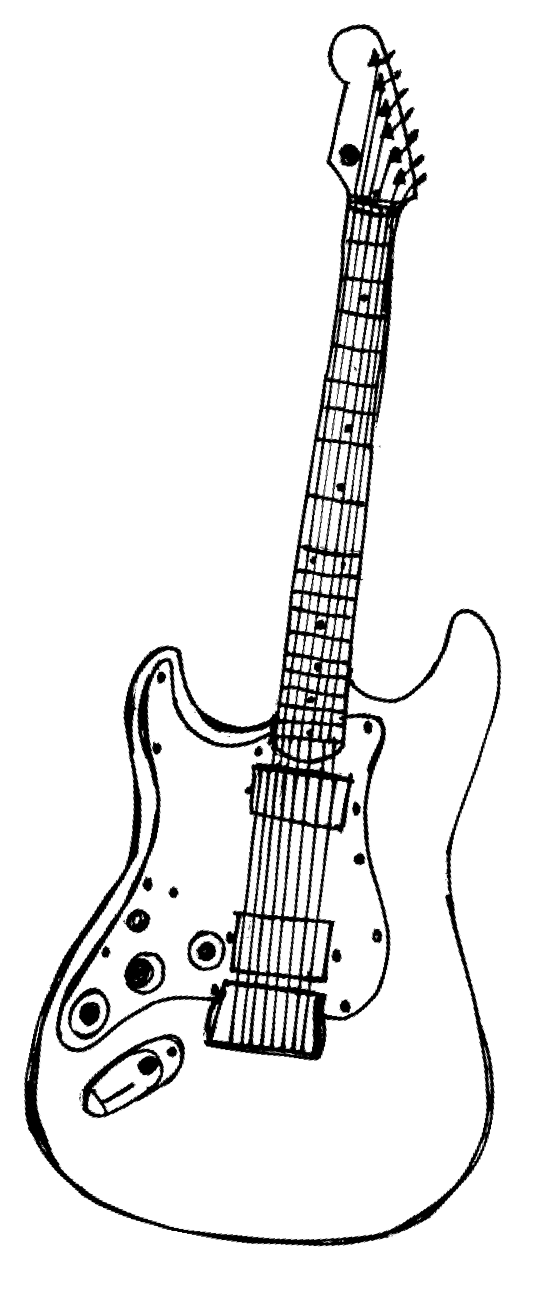Creative Sounds

Make your own music.

Try new instruments.

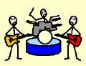

Creative music-making ensemble for young people aged 7 +

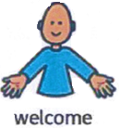

No previous experience required.

Inclusive to all needs and

abilities.

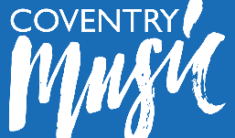

|  |  |
| --- | --- |
| **Creative Sounds Information** | |
| Image result for pecs symbol for family | If you have personal care or additional support needs, please bring a parent or PA to help you. |
|  | Thursdays |
|  | 5 – 6pm and 6 – 7pm Book on to one or both. |
| Image result for money symbol uk | Free |
|  | The Core Theatre, Solihull,  B91 3RG |

|  |  |
| --- | --- |
| **How to Register Interest** | |
| C:\Users\hradford\Downloads\writing.jpg | Fill in an **All About Me** form and send to [cbatty@solmus.solgrid.org.uk](mailto:cbatty@solmus.solgrid.org.uk) |
|  | Or call 0121 743 2483 |
| Image result for question mark symbol | For more information, contact Claire Batty [cbatty@solmus.solgrid.org.uk](mailto:cbatty@solmus.solgrid.org.uk) |

