**SAFEGUARDING POLICY**

**Date of Last Review:** 31st August 2024

**Review Period:**    *Annual*

|  |  |  |  |  |  |
| --- | --- | --- | --- | --- | --- |
| **Role** | | **Name and Title** | | **Contact** | |
| **Designated Safeguarding**  **Lead (DSL)**  *For all concerns related to a child’s well-being or safety* | | **Mark Steele**  *Coventry Music Lead* | | 07908 175 929    mark.steele@coventry.gov.uk | |
| **Deputy Designated**  **Safeguarding Lead (DDSL)**  *For all concerns related to a child’s well-being or safety* | | **Mark Allison**  *Learning and Development*  *Lead*    **Mark Patton**  *Learning and Development Lead*    **Claire Tyler**  *Learning and Development Lead* | | 07941551395  [mark.allison@coventry.gov.uk](mailto:Mark.patton@coventry.gov.uk)      07590 443 788  [Mark.patton@coventry.gov.uk](mailto:mark.allison@coventry.gov.uk)    07852 953586  [Claire.tyler@coventry.gov.uk](mailto:Claire.tyler@coventry.gov.uk) | |
| **Coventry Music Lead** | | **Mark Steele**  *Coventry Music Lead* | | 07908 175 929    mark.steele@coventry.gov.uk | |
| **Educational Visits Co-ordinator** | | **Mark Patton**  *Learning and Development Lead* | | 07590 443 788    mark.patton@coventry.gov.uk | |
| **Data Protection Lead** | | **Claire Tyler**  *Learning and Development Lead* | | 07852 953586  [Claire.tyler@coventry.gov.uk](mailto:Claire.tyler@coventry.gov.uk) | |
| **Line Manager to Coventry Music Lead** | | **Rachael Sugars**  *Strategic Lead Education and SEND* | | 02476977278    rachael.sugars@coventry.gov.uk | |
| **Local Authority**  **Designated Officer (LADO)**  *For allegations against persons working with children and young people* | | *Local Authority Designated Officer* | | 02476 975 483    lado@coventry.gov.uk | |
| **Reviewed by:**  Mark Allison  *Learning and Development Lead* | | **Approved by:** Mark Steele  *Coventry Music Lead* | |

**CONTENTS**

1. **INTRODUCTION**
2. *Purpose and Objectives*
3. *Definitions*
4. *Statutory Framework*
5. *Roles and Responsibilities*
6. *Coventry Music Hub Partners*
7. *Inter-Agency Working*

1. **SAFE WORKING PRACTICES**
2. *Code of Conduct*
3. *Appropriate Teaching Spaces*
4. *Health and Safety*
5. *Educational Visits and Live Music Events*
6. *Safeguarding Training*
7. *Emergency Procedures, including lockdown of educational settings*
8. *Disclosure and Barring Service (DBS) Checks*
9. *Safer Recruitment*
10. *Freelance Practitioners, Volunteers and Work Experience Placements*

1. **DATA PROTECTION**
2. *Data Protection*
3. *Data Sharing*
4. *Photography and Videos*

1. **E-SAFETY**
2. *Use of Social Media*
3. *Online Communication with Children and Parents*
4. *Use of Mobile Phones and Devices*
5. *Internet Use*

|  |  |
| --- | --- |
| 1. **CAUSES FOR CONCERN**   *5.1* *Types and Indicators of Abuse*  *5.2* *When to Report a Concern*  *5.3* *Procedures for Reporting a Concern*  *5.4* *Dealing with a Disclosure*  *5.5* *Guidelines for Referring a Safeguarding Issue*  *5.6* *Allegations Against a Member of Staff*  *5.7* *Self-Reporting*  *5.8* *Confidentiality*  *5.9* *Whistle-Blowing*    **APPENDICES** | |
| *Appendix A* | *List of Coventry Music Hub Partners* |
| *Appendix B* | *Code of Conduct* |
| *Appendix C* | *Hub Partners Safeguarding Declaration* |
| *Appendix D* | *Risk Assessment Pro Forma* |
| *Appendix E* | *Privacy Notice* |
| *Appendix F* | *Image Consent Form* |
| *Appendix G* | *Procedures for Reporting Concerns* |
| *Appendix H* | *Guidelines for Dealing with a Disclosure* |
| *Appendix I* | *Cause for Concern Form* |
| *Appendix J* | *Incident Review Form* |
|  |  |

**1** **INTRODUCTION**



**1.1** **Purpose and Objectives**

Coventry Music (the Local Authority Music Service) is the lead organisation of the Heart of England Music Hub, the major provider of music education across Coventry. The Service works alongside schools and Hub Partners to provide an inclusive, rich and balanced programme along with opportunities for training and development. Our role is to ensure high-quality teaching and learning for children and young people from all backgrounds across the city, deepening their enjoyment of music and supporting progression to the highest levels of excellence. We also provide a number of high-profile performance opportunities to showcase talent, progress and achievement.

Coventry Music fully recognises its statutory duty of care to ensure that all children and young people are healthy, safe, happy, and able to achieve their full potential. The nature of Coventry Music’s work, involving regular and sustained contact with children, leaves staff well-placed to observe the outward signs of abuse. This policy is designed to address all safeguarding issues including specific advice for those who work in music education.

The main Safeguarding objectives of the Service are:

* To have a clear, up-to-date safeguarding policy that is available to all stakeholders
* To raise awareness of safeguarding issues within the Service and the Hub
* To establish and maintain a safe and secure environment in which children can learn and develop to their full potential
* To develop and implement procedures for identifying and reporting cases, or suspected cases, of abuse
* To ensure that children are encouraged to talk and be listened to, and know that they can approach staff if they are worried
* To support pupils who have been abused in accordance with their agreed child protection plan
* To check the suitability of all staff to work with children and ensure that any unsuitable behaviour is reported and addressed appropriately
* To provide regular safeguarding training and updates, so staff can develop their confidence in recognising and reporting signs of abuse

**1.2** **Definitions**

For the purpose of this policy document:

“The Service” refers to Coventry Music, the lead organisation of the Heart of England Music Hub.

“The Hub” refers to the Heart of England Music Hub, a tri music service organisation of Coventry, Solihull and Warwickshire music services who work together to create joined-up music education provision across the 3 Authorities. See **Appendix A** for a list of current Hub Partners.

“Staff” refers to all adults involved with Coventry Music activities, including: Coventry Music employees, Business Support Services employees, self-employed tutors, freelance providers, Hub Partners supporting Coventry Music activities and events, and volunteers.

“Children” refers to all children and young people under the age of 18.

“Parents” refers to anybody with legal responsibility for a child, including birth parents, step parents, adoptive parents, foster parents, legal guardians, or the Virtual School.

“Safeguarding” refers to safeguarding and promoting the welfare of children, according to the definition in the government guidance *Working Together to Safeguarding Children (2018)*:

* Protecting children from maltreatment
* Preventing impairment of children’s health or development
* Ensuring that children grow up in circumstances consistent with the provision of safe and effective care
* Taking action to enable all children to have the best outcome

**1.3** **Statutory Framework**

In order to safeguard and promote the welfare of children, Coventry Music will act in accordance with the following legislation and statutory and non-statutory guidance:

* Procedures set out by the Coventry Safeguarding Children Board
* Keeping Children Safe in Education (2023) <https://www.gov.uk/government/publications/keeping-children-safe-in-education--2>
* Working Together to Safeguarding Children (2018)
* Information sharing: Advice for practitioners providing safeguarding services to children, young people and carers (2018)
* Right Help, Right Time (2018)
* Mandatory reporting of Female Genital Mutilation: Procedural information (2016)
* Guidance for safer working practices for those working with children and young people in educational settings (2015)
* What to do if you’re worried a child is being abused: Advice for practitioners (2015)
* Revised Code of Practice for Disclosure and Barring Service Registered Persons (2015)
* Revised Prevent Duty Guidance: for England and Wales (2015)
* Allegations of abuse against teachers and non-teaching staff (2012)
* Teachers’ Standards (2011)
* The Children Act (2004)
* The Sexual Offences Act (2003)
* The Education Act (2002, Section 175)

**Additional Non - Statutory Guidance**

https://www.gov.uk/government/collections/keeping-children-safe-in-out-of-school-settings.

**1.4** **Roles and Responsibilities**

The Service will:

* Appoint a Designated Safeguarding Lead (DSL) and a Deputy Designated

Safeguarding Lead (DDSL), who have received appropriate training and support for their roles

* Ensure all staff know the name and contact information of the DSL and DDSL
* Ensure all staff understand their responsibilities in being alert to the signs of abuse, and referring any concerns to the DSL or DDSL
* Ensure that all staff have access to, and understand, this policy
* Ensure that all staff hold valid safeguarding training and DBS clearance in accordance with this policy
* Ensure that all stakeholders (including parents) understand the responsibility placed on Coventry Music and its staff for child protection by making the Safeguarding Policy available on the website, and in hard copy on request
* Where appropriate, contact other agencies without first notifying parents, in partnership with Education Services and Social Care Services (N.B. this is a legal obligation and not a personal decision)
* Develop effective links with relevant agencies and co-operate as required with any enquiries regarding child protection matters, including attendance at case conferences

Coventry Music Lead will:

* Ensure that policies and procedures are fully implemented and followed by all staff, and reviewed on an annual basis
* Allocate sufficient time and resources to enable the DSL and DDSL to discharge their responsibilities
* Ensure that all staff feel able to raise concerns about poor or unsafe practice, and address any concerns sensitively and effectively in a timely manner
* Follow the procedures set out in this policy if an allegation is made against a member of staff

The Designated Safeguarding Lead (DSL) will:

* Be a member of the Senior Leadership Team
* Keep up to date with legislation, policy and guidance on safeguarding and child protection matters
* Co-ordinate action on safeguarding and child protection within the Service
* Be available for all staff to discuss and report any safeguarding concerns
* Keep written records of all information concerning safeguarding issues and concerns, even when the matter is not referred
* Ensure all safeguarding records are detailed, accurate, secure and confidential
* Refer cases of suspected or alleged abuse to the Referral and Assessment Service
* Liaise as appropriate with the Local Authority and other agencies
* Represent Coventry Music at any Child Protection Conferences, or arrange for a representative from the Service to attend in his/her absence, and ensure that any recommendations are carried out
* Pass any allegations against a member of staff to the Head of Service

The Deputy Designated Safeguarding Lead will:

* Be a member of the Senior Leadership Team
* Keep up to date with legislation, policy and guidance on safeguarding and child protection matters
* Support the DSL in fulfilling their role
* Be prepared to take on all duties of the DSL in his/her absence

All staff will:

* Follow the guidance and procedures set out in this policy, including the Code of Conduct set out in **Appendix B**
* Complete relevant training courses as directed by the Service
* Ensure they are aware of their responsibilities for safeguarding in being alert to the signs of abuse and to record and report any concerns
* Take seriously any disclosures made to them and provide reassurance to the discloser through their responses and behaviour
* Report any concerns about a child to the DSL, and provide a signed and dated written record of those concerns
* Know who the DSL is in each school where they work, and request this information if it is not clearly displayed within the school
* Understand the need for clear boundaries for professional relationships with children and families

**1.5** **Coventry Music Hub Partners**

Coventry Music values its relationships with partners on the Heart of England Music Hub, and recognises that all partners must share the responsibility for safeguarding children. All partners are expected to complete a Heart of England Music Hub Partners Safeguarding Agreement every year (see **Appendix C**).

Hub Partners must:

* Be committed to ensuring that all children using their services are healthy, safe, happy, and able to achieve their full potential
* Have a Safeguarding Policy that is reviewed on an annual basis, and is readily available to all stakeholders (or adopt the Coventry Music Safeguarding Policy)
* Appoint a Designated Safeguarding Lead within their organisation

Hub Partner staff (including self-employed workers and volunteers), whose roles involve working with children, must:

* Hold valid DBS clearance
* Attend basic safeguarding training on a regular basis
* Be aware of their responsibilities for safeguarding children
* Be able to recognise the key signs of abuse, and be aware of the procedures for recording and reporting concerns
* Understand the need for clear boundaries for professional relationships with children and families

**1.6** **Inter-Agency Working**

It is not viable for any single practitioner to have a full picture of a child’s needs and circumstances and, if children and families are to receive the right help at the right time, everyone who comes into contact with them has a role to play in identifying concerns, sharing information and taking prompt action.

Whenever necessary, Coventry Music will contribute to inter-agency working in line with statutory guidance *Working Together to Safeguard Children (2018)*. This may include working with social workers, the police, health services and others to promote the welfare of children and protect them from harm.

**2** **SAFE WORKING PRACTICES**



**2.1** **Code of Conduct**

All staff are expected to follow the Code of Conduct (see **Appendix B**), which includes guidelines on working safely and appropriately with children.

Personal relationships with children

Staff must not create a personal relationship with a child where one does not already exist; this includes spending time with children outside of a work setting. If a child displays inappropriate conduct towards staff such as overly-friendly or informal behaviour, this must be sensitively but firmly discouraged. Any concerns should be reported to the Coventry Music Senior Leadership team.

Staff must always be sensitive to how a child may interpret their actions and words, however well-intentioned, especially within a one-to-one setting. It is never appropriate to make suggestive or inappropriate remarks or jokes about, to, or in the presence of, a child.

Staff may accept gifts from children or families as part of their role but must ensure that these are not of significant value or intent.

Physical contact with children

Staff must not make any physical contact with a child unless there is a sound educational reason to do so, such as correcting a hand position on a musical instrument. This should be kept to a minimum, and always with sensitivity to the context and the child.

Sexual relationships with children

It is a criminal offence for an adult to engage in any sexual activity (even consensual) with any child under the age of 16, or a child under the age of 18 to whom the adult is in a position of trust; this includes grooming children with the intention of engaging in future sexual activity.

Online communication and social media

*For guidance regarding online communication and social media, see the E-Safety section of this policy.*

Sanctions and rewards

Sanctions should be given in accordance with the behaviour policy of the school or educational setting where activities are taking place. Punishments must never be disproportionate, unfair, physical or humiliating. Staff must not use physical force or restraint when addressing student behaviour and should call an appropriately trained member of staff for assistance if required.

Rewards should be given in accordance with the behaviour policy of the school or educational setting where activities are taking place. Staff may choose to give rewards or gifts to children as part of an agreed reward system; this must be applied fairly and transparently, and never involve monetary gifts.

Photographs and videos

*For guidance on the use of photography and video recording, see the Data Protection section of this policy.*

Transportation of children

If it is necessary for Coventry Music to provide transport for any children to or from an activity, there must be at least two members of staff present, and the driver must be a contracted member of Coventry Music staff. If using a car, the driver must hold suitable car insurance including cover for business use. If using a minibus, the driver must have completed Coventry City Council’s Minibus Driving Course (MIDAS), or a refresher course, within the last three years.

*For further guidance, see Coventry City Council’s Driving Policy.*

**2.2** **Appropriate Teaching Spaces**

Lessons or activities in a school must take place in a room that is large enough to work comfortably and safely, bearing in mind the number of students, and the instruments or equipment being used. The teaching room should not be in an isolated location in the school, and must have either windows, or an open door.

If a member of staff is asked to teach in a space that is not fit for purpose (including cupboards, windowless rooms, or isolated areas of the school), they must ask for an alternative room to be provided, otherwise the activity cannot go ahead. Any concerns should be reported to the Coventry Music Senior Leadership team, who will contact the school to put suitable safeguarding measures in place.

Activities outside of school must take place in a setting that has been approved by the Coventry Music Senior Leadership team. Lessons delivered on behalf of the Service must never take place in a child or staff member’s home face: face, exceptions can be made for online delivery.

**2.3** **Health and Safety**

A child’s health should always be put first during lessons and activities and it is important that children are observed for signs of tiredness or illness and appropriate action taken when needed. This may be as simple as suggesting a child sits and rests for a moment (particularly when playing a wind instrument or singing). If a child continues to feel unwell, they should be taken to an appropriate member of school staff.

All Coventry Music activities taking place out of school time are subject to a risk assessment (see **Appendix D**). The risk assessments will be shared with all staff involved in running the activity, and all staff must comply with any required actions and recommendations. The assessments will be reviewed every two years, or sooner if there has been a significant change to the potential risks.

All staff involved with Coventry Music activities outside of school hours must undertake first aid training or provide a valid certificate of a first aid training course, before commencing the work, or as soon as possible after commencing the work. First aid training must be updated every three years.

All Coventry Music ensemble rehearsals will be attended by at least one trained first aider. If none of the ensemble directors have completed or renewed their first aid training, the Service will arrange for a qualified additional member of staff to attend.

All venues used to host Coventry Music ensembles will have a combination-locked locker containing a first aid kit, accident book, and registers containing necessary medical information and emergency contact details. If any first aid is given (even minor instances), this must be recorded in the book, and the Service must be informed.

In case of a serious medical emergency outside of school hours, the parent or carer will be immediately contacted. If necessary, staff will call for an ambulance and may need to accompany the child to hospital until the parent or carer arrives.

**2.4** **Educational Visits and Live Music Events (including Child Licensing)**

*For guidance on planning and supporting performances, events, trips and tours (including Child Licensing requirements), see the Events Policy* [Coventry Music Events Policy 2024-2028.docx](https://coventrycc.sharepoint.com/:w:/r/teams/People/EduLibAdLearning/EducationEnt/CovMusicService/Documents/Events/Coventry%20Music%20Events%20Policy%202024-2028.docx?d=w309523e84ff1406cab573af61257ec27&csf=1&web=1&e=7xsC8e)

**2.5** **Safeguarding Training**

All new staff will undertake safeguarding training or provide a valid certificate from a safeguarding training course approved by the DSL, before commencing any work for the Service.

All staff will update their safeguarding training every two years. Once two years has elapsed, staff must complete an appropriate training course before the start of the following half term, or all work for Coventry Music will be suspended until training has been completed.

Coventry Music will provide one free safeguarding training course at the start of each academic year, open to all staff and Hub Partners. Staff who do not attend this course must undertake an alternative course, approved by the DSL, at their own cost.

Briefings and updates on safeguarding issues will be provided on an annual basis, or more frequently when necessary, to ensure that all staff are familiar with any changes to policy or legislation as they occur.

The DSL and DDSL will attend the LSCB Level 2 ‘Working Together to Safeguard Children’ training, and then undertake refresher safeguarding training or subsequent courses at Level 2 or Level 3 at least every two years.

Any newly appointed DSL or DDSL will attend the LSCB Level 2 ‘Working Together to Safeguard Children’ training before taking lead responsibility for safeguarding.

**2.6  Lockdown, Invacuation, and Evacuation Procedures**

Whether working within a school setting or delivering after school groups and workshops in an external venue about the best thing to do if there is a threat to children and young people in your care is challenging but it is vitally important to carry out this activity.

There are several wider circumstances where you may need to chaperone children and young people from one location to another, safely and very quickly. For example, a lock down, invacuation or evacuation might be necessary in any of the following occasions:

An armed intruder

A chemical or radiation leak

Out of control animal (Dogs, Bees, Horses)

Civil Unrest

A hostile intruder

Police Incident

Attempted abduction (whether by an estranged parent or stranger)

A fire in the local area / smoke / air pollution

A major incident, e.g. car accident, plane crash

Continued...

At the simplest level, a lockdown procedure has the same principle, whatever the nature of the threat.

**Be Safe, Get to Shelter, Act Fast**

Thebasic steps will always be:

Raise the alarm

Get the children to a place of safety

Alert the emergency services

Schools and venues will have a policy in place which will provide steps to follow as a visitor to their setting. For Coventry Music’s after school bands, rehearsals, and holiday activities Lockdown procedure and Evacuation procedure can be found here:

[Lock down procedure.docx](https://coventrycc.sharepoint.com/:w:/r/teams/People/EduLibAdLearning/EducationEnt/CovMusicService/Documents/Policies%20and%20Procedures/Emergency%20Lockdown%20Procedure%20for%20Group%20Nights/Lock%20down%20procedure.docx?d=w963a7ea87adb470b9c1f8c602450484b&csf=1&web=1&e=sIAnZt)

[Emergency evacuation.docx](https://coventrycc.sharepoint.com/:w:/r/teams/People/EduLibAdLearning/EducationEnt/CovMusicService/Documents/Policies%20and%20Procedures/Emergency%20Lockdown%20Procedure%20for%20Group%20Nights/Emergency%20evacuation.docx?d=w665f8f23f732468d98b19e999850eaef&csf=1&web=1&e=usBXq2)

For more guidance, please follow the link [https://www.outofschoolalliance.co.uk/lockdown-procedure](https://www.outofschoolalliance.co.uk/lockdown-procedure )

**Disclosure and Barring Service (DBS) Checks**

New Staff

All new staff will be the subject of an Enhanced Disclosure and Barring Service (DBS) check, undertaken by the Local Authority at no cost to the staff member.

If the new member of staff does not already hold a valid DBS certificate from another employer, the DBS check must be completed before undertaking any work on behalf of the Service.

If the new member of staff does already hold a valid DBS certificate from another employer, this can be used as an interim measure while waiting for a new DBS check to be processed. The staff member must have completed the online application form and presented appropriate identification before undertaking any work on behalf of the Service.

Alternatively, staff members may choose to subscribe to the DBS Renewal Service (at their own cost). If evidence is provided that a staff member is subscribed to the DBS Renewal Service, along with a valid DBS number, an additional DBS check will not be required.

Civil, legal or disciplinary action could be taken against any member of staff who fails to disclose any relevant convictions or cautions when applying to work for Coventry Music.

Existing Staff

All staff DBS checks will be renewed every three years; although this is not a statutory requirement, it is considered good practice and has been adopted as policy by the Service. Once three years has elapsed, staff must start the process for renewing a DBS check before the start of the following half term, or all work for Coventry Music will be suspended until the process has been started.

Alternatively, staff members may choose to subscribe to the DBS Renewal Service (at their own cost). If evidence is provided that a staff member is subscribed to the DBS Renewal Service, along with a valid DBS number, further DBS checks will not be required.

Each staff member must always wear a photo ID badge indicating their DBS number when working on behalf of Coventry Music. Staff not wearing photo ID may be refused entry to schools and other educational settings and will not be reimbursed for the lost time.

Civil, legal or disciplinary action could be taken against any member of staff who fails to disclose any relevant convictions or cautions they receive while working for Coventry Music.

Handling of DBS Information

DBS numbers will be securely held by Coventry Music and shared with any schools visited by the staff member. In accordance with the DBS Code of Practice, Coventry Music will not retain a copy of the certificate or provide a copy for any school. Staff are not expected to produce the certificate for inspection, even if requested to do so by a school or other educational setting; any such requests should be reported to the Coventry Music Senior Leadership team.

If a disclosure is made during the DBS check, this will be treated as highly confidential. In accordance with the DBS Code of Practice, such information can only be shared with relevant persons in the course of their duties relevant to recruitment and vetting processes. The DSL (or DDSL) will assess whether the disclosure is relevant to the role, and whether any additional measures need to be put in place.

**2.7** **Safer Recruitment**

Coventry Music adheres to a Safer Recruitment Policy, which has clear procedures for appointing new staff, including requests for references, DBS checks, identity checks and right to work in the UK checks.

**2.8** **Freelance Practitioners, Volunteers and Work Experience Placements**

Coventry Music welcomes the role of freelance practitioners and volunteers in supporting activities, events and concerts. This must be discussed with the Coventry Music Senior Leadership team in advance, who will complete a risk assessment (see **Appendix D**) and ensure that appropriate safeguarding measures are put in place.

Freelance practitioners / volunteers working with Coventry Music on an occasional basis must always be supervised by a member of Coventry Music staff when working with, or around, children or young people. As far as possible, volunteers should be assigned to public-facing roles, e.g. ticket sales.

Freelance practitioners / volunteers working with Coventry Music on a regular basis must meet the same DBS and safeguarding training criteria as Coventry Music staff.

Any students placed within Coventry Music as part of a work experience programme must always be supervised and are bound by the Code of Conduct outlined in this policy (see **Appendix B**). If the student is under 18 years old, they are entitled to the same safeguarding protections as any other child.

**3** **DATA PROTECTION**



**3.1** **Data Protection**

Staff who receive information about children and their families in the course of their work should share that information only within appropriate contexts.

Any pupil records (including records of disclosures of abuse or safeguarding concerns) will be kept for the duration of the child's contact with Coventry Music. If a child moves to another Local Authority or changes provider, the records will be forwarded to the DSL at the new Local Authority or provider. Coventry Music will retain a receipt for the records signed by the receiving Local Authority or provider.

Data will be processed in line with the six principles of the General Data Protection Regulation:

1. Lawfulness, fairness and transparency
2. Purpose limitation
3. Data minimisation
4. Accuracy
5. Storage limitation
6. Integrity and confidentiality



Coventry Music and Coventry City Council have produced a Privacy Notice (see **Appendix E**) explaining how personal information is used.

**3.2** **Data Sharing**

Information sharing is essential for effective safeguarding and promoting the welfare of children and young people. It is a key factor indicated in many serious case reviews, where poor information sharing has resulted in missed opportunities to take action that keeps children and young people safe.

In certain circumstances, the Data Protection Act (2018) allows Coventry Music to share personal information without consent. This applies when there is a safeguarding risk to a child and the Service cannot reasonably expect to gain consent or seeking consent would put a child at further risk. In this case, Coventry Music will share information with the Multi Agency Safeguarding Hub or other appropriate agencies in line with the seven principles:

1. Necessary and proportionate
2. Relevant
3. Adequate
4. Accurate
5. Timely
6. Secure
7. Recorded

The following flowchart, from *Information Sharing: Advice for practitioners providing safeguarding services to children, young people, parents and carers*, can be used to assess whether it is appropriate to share information. If in doubt, staff should contact Coventry Music’s Data Protection Lead or DSL.

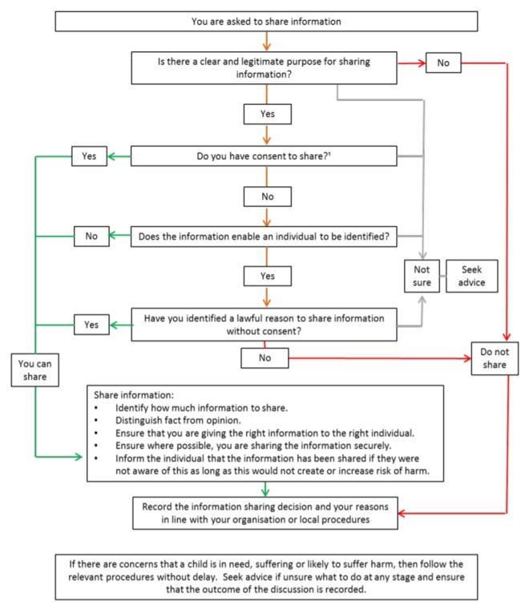

Coventry Music’s Data Sharing Agreement is available on request and sets out the principles and procedures that all Hub Partners should adhere to when sharing personal data.

**3.3** **Photography and Videos**

Coventry Music and Hub Partners may use photographs or videos to celebrate achievements and promote events and activities. Such images must be used with caution and stored and used in accordance with the data protection principles of the GDPR. Images of children must never be used for anything other than the intended purpose.

Children appearing in photographs and videos must be appropriately dressed and must may only be identifiable by name or any other personal information when appropriate is consent is given; this includes information provided in any accompanying text.

Coventry Music will obtain written parental consent before any photographs or videos are taken. This is not only a legal requirement, but a serious safeguarding issue, for example in cases where children have been removed from an environment of domestic abuse. All consent forms for Coventry Music ensembles and events include a section about photo consent, and a standard Coventry City Council image consent form can be used for other purposes (see **Appendix F**).

Staff may use photographs and videos for assessment purposes, to celebrate musical achievements, or to promote activities. It is strongly recommended that photographs and videos should be taken by members of school staff whenever possible. If this is not possible, plans to take photographs and videos must be agreed with the school in advance. Images of children should never be taken or stored on a personal device. If an appropriate school or work device is not available, staff should instead consider taking audio recordings using an MP3 recorder or similar device.

Photographs and videos at Coventry Music events should be taken by an official photographer, or appointed member of staff. The official photographer must hold a valid DBS certificate, and will be made aware of any children for whom image consent has not been given. If an official photographer has not been provided, staff may take photographs or videos on a work device in accordance with the policy outlined above.

**4** **E-SAFETY** 

**4.1** **Use of Social Media**

All staff must be aware that their online conduct can have an impact on their role and reputation, and that of Coventry Music and Coventry City Council. Caution and professional judgement should be applied to how a member of staff uses social media websites and apps. Staff must always check privacy settings carefully and consider carefully whether it is appropriate to connect with colleagues or parents on social media, and what personal information, images etc. are shared with them. Any information shared online can easily be circulated more widely than intended without the consent or knowledge of the original poster.

Any information shared through social media, even when shared privately, is subject to copyright, data protection, Freedom of Information and safeguarding legislation. These regulations apply both for work and personal use, whether during work hours or otherwise.

Civil, legal or disciplinary action could be taken against any member of staff found to have brought the profession or institution into disrepute or behaved in a manner that undermines confidence in their professional abilities. Examples include, but are not limited to:

* Divulging sensitive information about pupils, parents or colleagues
* Making comments that may constitute harassment, victimisation or bullying
* Discriminating based on race, religion, gender, sexual orientation, age or disability
* Posting illegal, sexual or offensive content
* Joining groups or forums deemed to be inappropriate for Coventry Music staff
* Publicly criticising the service or a partner organisation

**4.2** **Online Communication with Children and Parents**

All staff must work within professional boundaries to protect themselves and the children they work with.

Staff must not use any online communications (including email, text messaging or social media) to contact children directly. If there is a pre-existing relationship, e.g. family members or close family friends, it is the member of staff’s responsibility to ensure that the nature of the relationship, and of any information shared, is appropriate. Any concerns should be reported to the Coventry Music Senior Leadership team.

As far as possible, communication between staff and parents should be through written messages in practice diaries. If necessary, staff may use an appropriate form of online communication (including email or text messaging) to contact parents to make arrangements for lessons and other musical activities. It is strongly recommended that a dedicated work email address or phone number is used for this purpose.

**Children absent/missing from Education**

Coventry Music understands that children that are absent from education for prolonged periods and/or repeat occasions can act as a vital warning sign to a range of safeguarding issues including neglect, child sexual and criminal exploitation – particularly county lines**. This includes children missing from education that are not on roll.**

**4.3** **Use of Mobile Phones, Smart Watches and Devices**

Staff must be aware of, and comply with, whatever policy is in place at each school and educational setting they visit.

*For guidance on taking and storing photographs or videos of children on mobile phones and devices, see the Photography and Videos section of this policy.*

**4.4** **Internet Use**

Staff accessing the internet during working hours, or using Coventry City Council equipment, are bound by Coventry City Council’s ICT Acceptable Usage policy, which can be supplied on request.

Some lessons or activities may require children to browse the internet. Staff must be aware of, and comply with, the internet policy of whatever setting they are working in. Activities involving internet use must be planned carefully and responsibly, and it is the responsibility of all adults in the room to monitor internet use and remind children of the importance of being safe online.

Staff using the internet in the classroom should be aware of the ‘SMART rules’ devised by Childnet International:

|  |  |
| --- | --- |
| **SAFE** | Keep safe by being careful not to give out personal information when you’re chatting or posting online. Personal information includes your email address, phone number and password. |
| **MEETING** | Meeting someone you have only been in touch with online can be dangerous. Only do so with your parents’ or carers’ permission and even then, only when they can be present. Remember online friends are still strangers even if you have been talking to them for a long time. |
| **ACCEPTING** | Accepting emails, IM messages, or opening files, pictures or texts from people you don’t know, or trust can lead to problems – they may contain viruses or nasty messages! |
| **RELIABLE** | Someone online might lie about who they are and information on the internet may not be true. Always check information with other websites, books or someone who knows. If you like chatting online it’s best to only chat to your real-world friends and family. |
| **TELL** | Tell your parent, carer or a trusted adult if someone or something makes you feel uncomfortable or worried, or if you or someone you know is being bullied online. |

*For further information and guidance on internet safety, see http://www.childnet.com.*

**5** **CAUSES FOR CONCERN**

**5.1** **Types and Indicators of Abuse**

It is important that all staff are aware of the signs and behaviours which may indicate abuse.

There are four main categories of abuse, which may result in a child being placed on the Child Protection Register: physical, emotional, sexual and neglect. Staff should also be aware of more specific safeguarding issues, including Female Genital Mutilation and Radicalisation.

It is important to remember that not all child abuse is perpetrated by adults – children and young people can bully and abuse each other emotionally, physically or sexually, and this should be taken just as seriously. Bullying can be face-to-face, through phone calls or text messages, or using social media websites or apps. It can cause considerable distress, affect health and development, and lead to significant harm including the inducement of self harm. Children and young people who bully or abuse are likely to have considerable needs themselves, as well as posing a significant risk of harm to others.

Physical Abuse

Deliberately hurting a child, including: hitting, pinching, shaking, throwing, poisoning, burning, scalding, drowning or suffocating. Physical abuse can also involve an adult fabricating, or deliberately inducing, symptoms of illness in a child.

The following signs, either individually or in combination, may indicate physical abuse. Staff must remember that these are only indicators and avoid making any assumptions.

* Unexplained, untreated or recurrent injuries (including burns)
* Improbable explanations of injuries
* Arms and legs covered, even in hot weather
* Refusal to undress (e.g. changing into PE kit)
* Bald patches
* Descriptions of inappropriate or excessive punishments
* Withdrawal from physical contact
* Fear of returning home
* Fear of medical help
* Self-destructive tendencies
* Aggression towards others
* Running away

Emotional Abuse

Persistent emotional maltreatment of a child, including: making a child feel worthless, unloved or inadequate, not giving the child the opportunity to express themselves, or ridiculing a child. Emotional abuse can also involve setting inappropriate expectations of a child, or not allowing children to develop independence at an appropriate level for their age and stage of development.

The following signs, either individually or in combination, may indicate emotional abuse. Staff must remember that these are only indicators and avoid making any assumptions.

* Over-reaction to mistakes
* Continual self-deprecation
* Self-harm or mutilation
* Fear of parents being contacted
* Descriptions of inappropriate or excessive punishments
* Fear of new situations
* Inappropriate emotional responses to situations
* Neurotic behaviour (e.g. thumb sucking, hair twisting, rocking)
* Compulsive stealing or scavenging
* Extremes of passive or aggressive behaviour
* Drug abuse
* Running away
* Delayed physical / mental / emotional development
* Sudden speech disorders

Sexual Abuse

Forcing or enticing a child to take part in sexual activities, whether they are aware of what they are doing, including: inappropriate physical contact, sexual exploitation, involving children in producing or looking at sexual images or activities, or grooming a child for future sexual abuse.

The following signs, either individually or in combination, may indicate sexual abuse. Staff must remember that these are only indicators and avoid making any assumptions.

* Sudden changes in behaviour / school performance
* Inappropriate sexual knowledge, language or behaviour
* Depression and withdrawal
* Phobias or panic attacks
* Secretive behaviour
* Tendency to cling or need reassurance
* Regression to younger behaviour (e.g. thumb-sucking, or playing with old toys)
* Distrust of a familiar adult (e.g. relative, family friend, babysitter, neighbour, lodger)
* Fear of undressing (e.g. changing into PE kit)
* Unexplained gifts or money
* Bedwetting, daytime wetting and/or soiling
* Sleep disturbances and nightmares
* Complaints of genital pain or itching, or anal pain
* Chronic illness (e.g. throat infection, venereal disease or another STD)
* Eating disorders (e.g. Anorexia, Bulimia)
* Unexplained pregnancy

Neglect

Persistent failure to meet a child’s basic physical and/or psychological needs (such as food, clothing, shelter, protection from harm, supervision, or medical care). Neglect may occur if a parent or carer becomes physically or mentally unable to care for a child.

The following signs, either individually or in combination, may indicate neglect. Staff must remember that these are only indicators and avoid making any assumptions.

* Constant hunger or emaciation
* Compulsive stealing or scavenging
* Poor personal hygiene
* Poor state of clothing
* Untreated medical issues
* Constant tiredness
* Frequent lateness or non-attendance at school
* Running away
* Destructive tendencies
* Low self-esteem
* Neurotic behaviour
* Difficulty in building social relationships

Child on Child

ADD INFORMATION FROM DSL UPDATE

(formerly Peer on Peer)

Anyone under the age of 18 can be deemed as a victim or perpetrator – looking for signs of both through the above descriptions – all safeguarding concerns

Female Genital Mutilation

Female Genital Mutilation (FGM) refers to all procedures involving partial or total removal of the external female genital organs, or any other injury to the female genital organs for non-medical reasons. FGM is most often carried out on young girls between infancy and 15 years old, and can be referred to as ‘cutting’, ‘female circumcision’, ‘initiation’, ‘Sunna’, or ‘infibulation’. FGM is illegal and extremely harmful, and can cause long-term physical and mental harm, difficulty in giving birth, infertility, and even death.

Indicators that FGM has taken place, or that a girl is at risk, include:

* Mentioning a special procedure or occasion ‘to become a woman’
* Prolonged absence from school
* Family trip to the country of origin
* Reluctance or inability to take part in physical activity
* Bladder or menstrual problems
* Visits from a female family elder from the country of origin

If a girl under 18 discloses that FGM has taken place, there is a legal duty to inform the police as soon as possible – this is a personal obligation and cannot be transferred to an organisation or DSL.

If a member of staff hears a third-party report of FGM, or suspects that a girl under 18 is at risk of FGM, this must be treated as a serious safeguarding concern.

Radicalisation

Radicalisation is the act or process of encouraging extremist views or actions, including religious extremism and far-right political ideologies. While it remains rare for children to become involved in terrorist activity, children can be groomed from an early age through exposure to extremist influences or prejudiced views.

Schools have a statutory duty to protect pupils from the risk of extremism and radicalisation, and the Prevent strategy has been included in Ofsted’s framework and handbook since September 2015.

Indicators that a child is at risk of radicalisation include:

* Becoming distant or showing loss of interest in friends or activities
* Possession of materials or symbols associated with extremist causes
* Unexplained gifts or money

If a member of staff is concerned that a child may be at risk of radicalisation, they can contact the DfE’s Due Diligence and Counter Extremism Group (DDCEG) helpline, or the Anti-Terrorism Hotline, in confidence to raise a concern.

**Due Diligence and Counter Extremism Group Helpline**

020 7340 7264

**Anti-Terrorism Hotline**

0800 789 321

To make a Prevent referral, a referral form must be sent to both the West Midlands Police and the Coventry City Council MASH team.

**Prevent Referral Form**

http://www.coventry.gov.uk/downloads/file/23089/prevent_referral_form

**Email to:**

CTU_GATEWAY@west-midlands.pnn.police.uk

AND mash@coventry.gov.uk

**Domestic Abuse**

Coventry suffers high levels of domestic abuse. It does run a dedicated website: https://www.safetotalk.org.uk/

**5.2** **When to Report a Concern**

It is the responsibility of all staff to protect children and be vigilant to potential signs of abuse. Any concerns about a child’s wellbeing must be reported in accordance with this policy. It is important to remember that even a minor concern may be part of a larger pattern of abuse, and an abuser may also have access to other children.

There are several reasons why a child may not wish to report abuse:

* Actual or implicit threats from the abuser of reprisals or withdrawal of privileges
* Actual or implicit threats from peers also involved in abuse
* Fear that they are to blame and will be in trouble
* Guilt about taking part in abusing other children
* Fear of public exposure
* Fear of disturbance to their family / school life
* Emotional dependence on, or loyalty to, the abuser
* Belief that sexual abuse is normal, or part of a legitimate romantic relationship
* Confusion about their sexual identity
* Low sense of self-esteem
* Fear of not being believed
* Lack of faith in the justice system (particularly for ethnic minority children)
* Lack of appropriate language skills

There are a number of reasons why an adult may not wish to report concerns of abuse:

* Request for secrecy from the child, or a later retraction of a disclosure
* The 'rule of optimism' – belief that everything will work itself out
* Distraction by a temporary improvement in the child's situation
* Belief that another agency is responsible for dealing with the problem
* Assumption that a parent or carer will protect the child
* Fear they may have misinterpreted the situation or overreacted
* Belief that the child is fantasising or lying
* Fear of breaking up a family
* Fear of putting the child at risk of further abuse
* Fear of damaging a trusting relationship with the child or their family
* Fear of reprisals to themselves
* Fear of presenting evidence in court
* Painful personal memories of abuse
* Lack of awareness or understanding of correct safeguarding procedures

**5.3** **Procedures for Reporting a Concern**

All staff must follow the procedures for reporting a concern (see **Appendix G**), which includes guidelines on working safely and appropriately with children.

Safeguarding concerns during school hours 

1. Make an accurate written record of concerns immediately. The record must use the child’s own words, be signed, dated and timed, and kept securely. Any records could provide important evidence in the event of a court case.
2. Discuss concerns with the class teacher or school DSL by the end of the day.
3. Follow guidance from the school.
4. Notify the DSL for Coventry Music within five working days.

*For guidance on reporting concerns related to radicalisation, see the Types and Indicators of Abuse section of this policy.*

Safeguarding concerns outside school hours 

1. Make an accurate written record of concerns immediately. The record must use the child’s own words, be signed, dated and timed, and kept securely. Any records could provide important evidence in the event of a court case.
2. Discuss concerns with the Coventry Music DSL by the end of the following working day.
3. Follow guidance from Coventry Music.

*For guidance on reporting concerns related to radicalisation, see the Types and Indicators of Abuse section of this policy.*

Child not collected after an activity 

1. If a child has not been collected 10 minutes after the activity was due to end, try to contact the parent to arrange collection.
2. If the parent does not respond, continue trying to make contact whilst keeping the child calm.
3. If the child has not been collected after 30 minutes, call Coventry City Council’s Duty Social Worker (024 7683 2222).
4. Notify the Coventry Music admin team by the end of the following working day.

Immediate threat to a child’s safety 

1. In the case of a genuine emergency, with an immediate threat to a child’s safety, call the emergency services (999).

**5.4** **Dealing with a Disclosure**

A disclosure may come directly from a child, or from a third party (e.g. another child, a friend or family member, or a school colleague). Sensitive information may be disclosed at any time of day, including outside of normal lesson time, e.g. during break periods, before- and after-school clubs, and one-to-one lessons.

All staff must be aware of the guidance for dealing with a disclosure appropriately (see **Appendix H**).

Listening to the child 

If a child makes a disclosure, let them speak freely, and listen carefully. It is important to speak in a way that is appropriate to the child’s age and level of understanding (particularly being sensitive to the needs of EAL or SEND children), and remain calm - any negative responses (e.g. shock, anger or disbelief) can make the child feel like they have done something wrong, or will not be believed. Ask open questions if it is absolutely necessary for clarification, but do not ask leading questions, press the child for more information, or ask to see / photograph any injuries.

Reassure the child that they have done the right thing by speaking to you and explain what will happen next, without making any false promises. A child making a disclosure may ask that the information is kept secret. It is important to be clear that staff cannot promise complete confidentiality, because they have a responsibility to share relevant information with appropriate professionals to help keep the child and other children safe.

Next steps 

It is important to take any disclosures seriously, even if they seem difficult to believe, without jumping to any conclusions. Do not attempt to question the alleged perpetrator or discuss concerns with the child’s parents. In the event of a disclosure leading to a court case, evidence can easily be compromised by inappropriate questioning.

Make an accurate, written record, but do not ask the child to provide a written statement. The record must use the child’s own words, and not include any personal conclusions or judgements. In the event of a disclosure leading to a court case, evidence can easily be compromised by inaccurate reporting.

*For guidance on reporting concerns, see the Procedures for Reporting a Concern section of this policy.*

**5.5** **Guidelines for Referring a Safeguarding Issue**

The DSL will make the decision whether or not to refer the concern to Social Care, using the ‘Right Help, Right Time’ guidance from the Coventry Safeguarding Children Board. A referral to Children’s Social Care is mandatory if it is believed or suspected that a child is suffering, or likely to suffer, significant harm.

Coventry operates one central number for all issues relating to children’s social care and early help, including advice and referrals.

**Children's Social Care Referral and Assessment Service**

024 7678 8555

**Duty Social Worker (Out of Hours)**

024 7683 2222

Regardless of whether or not the concern was referred to Social Care, the DSL must complete a Cause for Concern Form (see **Appendix I**), which will be stored securely.

In the case of a safeguarding incident, near-miss, concern or complaint relating to a Coventry Music activity, the DSL, DDSL and Head of Service will investigate the incident thoroughly. An Incident Review Form (see **Appendix J**) must be completed, outlining what has happened, and what changes (if any) need to be made to current safeguarding policies or procedures. In the case of a repeated safeguarding incident, the Incident Review must lead to immediate action to prevent any further incidents.

**5.6** **Allegations Against a Member of Staff**

An allegation is any information which indicates that a member of staff:

* has behaved in a way that has, or may have, harmed a child
* has committed a criminal offence against, or in relation to, a child • poses a risk of harm if they work regularly or closely with children

This applies to any child the member of staff has contact with in their personal, professional or community life.

Any allegation must be taken seriously and reported as soon as possible. Failure to report an allegation is a potential disciplinary offence.

Allegations against a member of school staff must be reported to the Headteacher (or a deputy in his/her absence). Allegations against a member of Coventry Music staff must be reported to the Head of Service (or a member of the Senior Leadership Team in his/her absence). If the allegation concerns the Head of Service, the issue must be referred directly to his/her line manager, the Head of Education Entitlement.

The Headteacher / Head of Service will assess whether it is necessary to refer the concern to the Local Authority Designated Officer (LADO) for Education. If the allegation meets any of the three criteria set out above, then the Head of Service must contact the LADO within one working day, providing written confirmation of the allegation.

The role of the LADO is to provide advice, guidance and management of situations in which there is an allegation made against a person working with children and young people. The LADO will determine the nature and scope of the investigation and liaise with the police and other agencies.

**Local Authority Designated Officer**

LADO@coventry. gov.uk

024 7683 3443

**5.7** **Self-Reporting**

If a member of staff believes that they may have behaved inappropriately or is concerned that an allegation may be made against them, they must contact the Head of Service (or a member of the Senior Leadership Team in his/her absence) as soon as possible to discuss their concerns.

The Head of Service will assess whether it is necessary to refer the concern to the LADO.

*For guidance on reporting allegations against a member of staff to the LADO, see the Allegations Against a Member of Staff section of this policy.*

**5.8** **Confidentiality**

Any information relating to a safeguarding concern, disclosure, or allegation must be treated as highly confidential, and only shared within appropriate contexts. Any requests for access to information from non-Coventry Safeguarding Children Board Agencies must be referred to the Head of Service and DSL, who will seek legal advice before responding.

**5.9** **Whistleblowing**

The Council takes malpractice seriously and encourages people to speak out if they are aware of any actual or potential malpractice within the organisation. The Council is committed to creating an open culture, where concerns can be raised without fear of reprisals.

*Coventry City Council Whistleblowing Policy, 2007*

The NSPCC Whistleblowing Advice Line was commissioned by the Home Office in response to a recommendation for “a new whistleblowing national portal for child abuse related reports.” The line offers free advice and support to professionals with concerns about how child protection issues are being handled by an organisation. You can contact this line if you are concerned that:

* Coventry Music’s safeguarding procedures are not clear
* an issue is not being dealt with properly
* you are being treated unfairly regarding a safeguarding concern

A trained NSPCC practitioner will discuss your concerns, talk you through the whistleblowing process, and liaise with the relevant authorities. Calls can be made anonymously, and callers can request for contact details not to be shared with other agencies.

The Whistleblowing Advice Line does not replace any policies, procedures or responsibilities of Coventry Music or Coventry City Council. Members of staff should always raise concerns through the routes described in this policy in the first instance.

**NSPCC Whistleblowing Advice Line**

help@nspcc.org.uk

0800 028 0285

https://www.nspcc.org.uk/what-you-can-do/report-abuse/dedicatedhelplines/whistleblowing-advice-line/

**APPENDIX A – LIST OF COVENTRY MUSIC HUB PARTNERS**

|  |  |
| --- | --- |
| Armonico Consort | Arts Council England |
| Arts & Cultural Partnership | Coventry Cathedral |
| Coventry University | Creative Optimistic Visions |
| Drake Music | Mac Makes Music |
| Media Mania | Orchestra of the Swan |
| Positive Youth Foundation | Royal Birmingham Conservatoire |
| Talking Birds | The Tin Music & Arts |

**APPENDIX B – CODE OF CONDUCT**

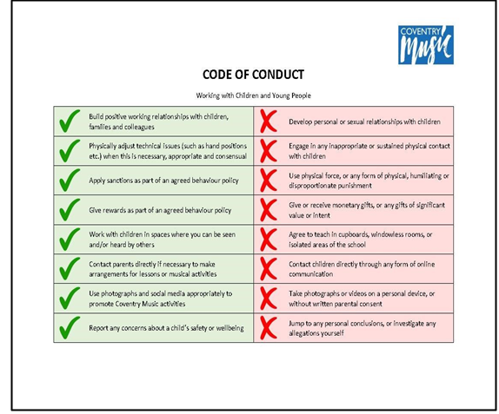



**HUB PARTNERS SAFEGUARDING DECLARATION**

|  |  |
| --- | --- |
| Name of Organisation |  |
| Name of DSL |  |
| Email address of DSL |  |
| Phone number of DSL |  |

Coventry Music values its relationship with partners on the Music Education Hub, and recognises that all partners must share the responsibility for safeguarding children and young people.

By completing this declaration, you are confirming that your organisation:

* Is committed to ensuring that all children and young people using your services are healthy, safe, happy and able to achieve their full potential
* Has a safeguarding policy that is reviewed on an annual basis, and is readily available to all stakeholders
* Has appointed a Designated Safeguarding Lead (DSL) within your organisation

You are also confirming that all of your staff (including self-employed workers and volunteers), whose roles involve working with children:

* Hold valid DBS clearance
* Attend basic safeguarding training on a regular basis (*N.B. Coventry Music runs a free safeguarding course at the start of every academic year).*
* Are aware of their responsibilities for safeguarding children and young people
* Is able to recognise the key signs of abuse, and is aware of the procedures for recording and reporting concerns
* Understand the need for clear boundaries for professional relationships with children and families

**Safeguarding Declaration completed by:**

|  |  |
| --- | --- |
| **Name** |  |
| **Job Title** |  |
| **Signature** |  |

**APPENDIX D – RISK ASSESSMENT PRO FORMA**

**Risk Assessment**

|  |  |  |  |
| --- | --- | --- | --- |
| **Risk Assessment Information** | | **Risk Assessment Undertaken By** | |
| **Event** |  | **Name** |  |
| **Date** |  | **Position** |  |
| **Location** |  | **Date** |  |

|  |  |  |
| --- | --- | --- |
| **On Duty Coventry Music Staff** | **Contact Number** | **First Aid Trained (yes/no)** |
|  |  |  |
|  |  |  |
|  |  |  |
|  |  |  |
|  |  |  |

|  |  |
| --- | --- |
| **Running Order** | **Time** |
|  |  |
|  |  |
|  |  |
|  |  |
|  |  |
|  |  |
|  |  |
|  |  |
|  |  |
|  |  |
|  |  |

Risk Assessment

|  |  |  |  |  |
| --- | --- | --- | --- | --- |
| **HAZARD**  *(what is it that could cause harm*) | **WHO**  *(who could be affected)* | **HOW**  *(what might be the possible effect)* | **CONTROL MEASURES CURRENTLY IN PLACE** | **ADDITIONAL CONTROLS** |
|  |  |  |  |  |
|  |  |  |  |  |
|  |  |  |  |  |
|  |  |  |  |  |
|  |  |  |  |  |
|  |  |  |  |  |
|  |  |  |  |  |

**APPENDIX E – PRIVACY NOTICE**

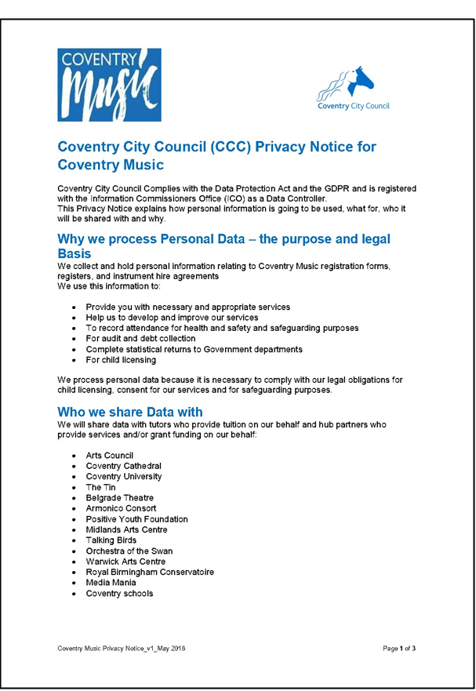

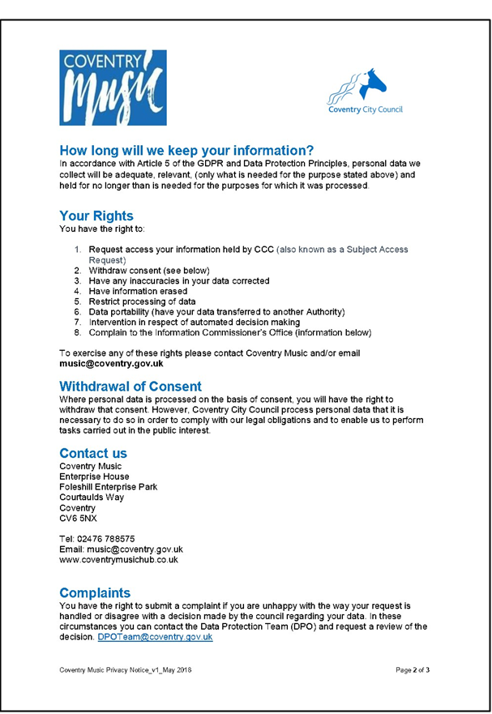

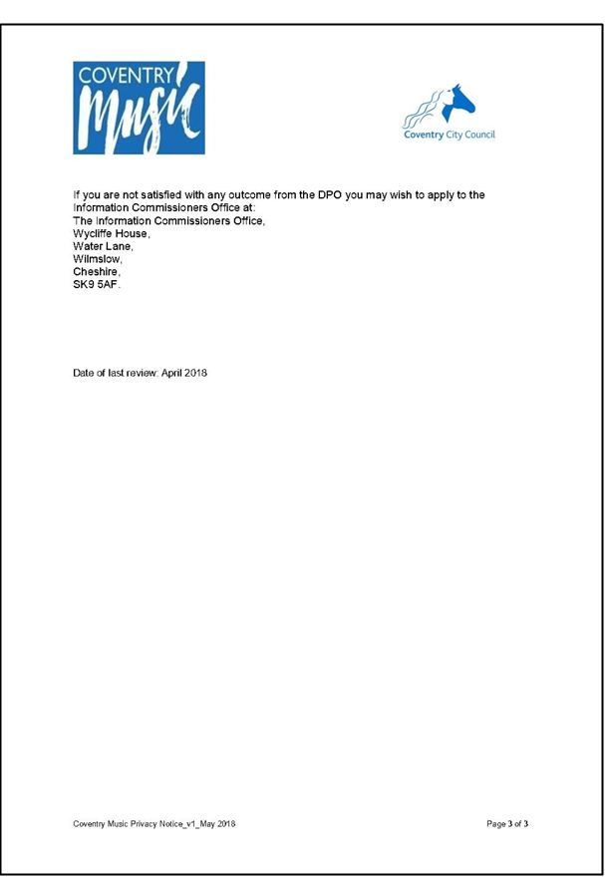

**Using Images of Children**

**Consent form for Coventry City Council Staff**

**commissioning photography**

Coventry City Council would like to take photographs of your child for promotional purposes. These images may appear in our printed or online publications.

Name of parent or guardian: __________________________________________________________

Address: __________________________________________________________________________

__________________________________________________________________________________

Name of Child: _____________________________________________________________________

Location of Photograph: ______________________________________________________________

May we use your child’s image in our printed promotional publications, websites, social media and other partner websites? Yes/ No

**Data Protection Act 1998** The Data Controller is Coventry City Council. The details you provide on this form will only be used in connection with Coventry City Council promotions and that of its partner organisations.

Please note that websites can be viewed throughout the world, not just in the United Kingdom where UK law applies.

Your signature: ___________________________________________________________________

Date: ______ / _____ / _______

**Conditions of use**

1. We will not include details or full names (which means first name and surname) of any child or adult in an image on video, on our website, or in printed publications, without good reason. For example, we may include the full name of a competition winner if we have their consent. However, we will not include the full name of a model used in promotional literature.
2. We will not include personal email or postal addresses, or telephone or fax numbers on video or on our website or in printed publications.
3. We will only use images of pupils who are suitably dressed, to reduce the risk of such images being used inappropriately.

**www.coventry.gov.uk**

**PROCEDURES FOR REPORTING CONCERNS**

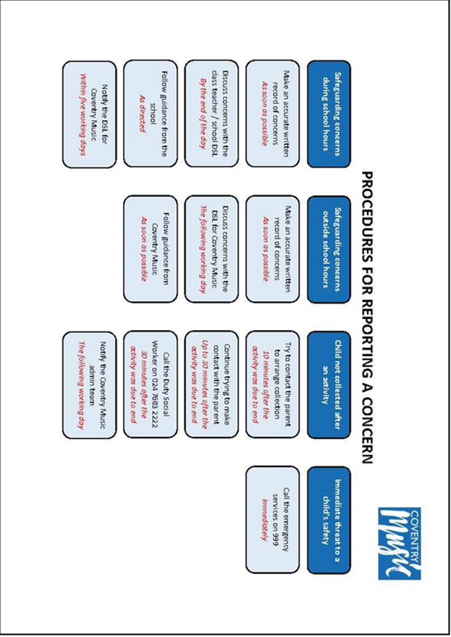

**GUIDELINES FOR DEALING WITH A DISCLOSURE**

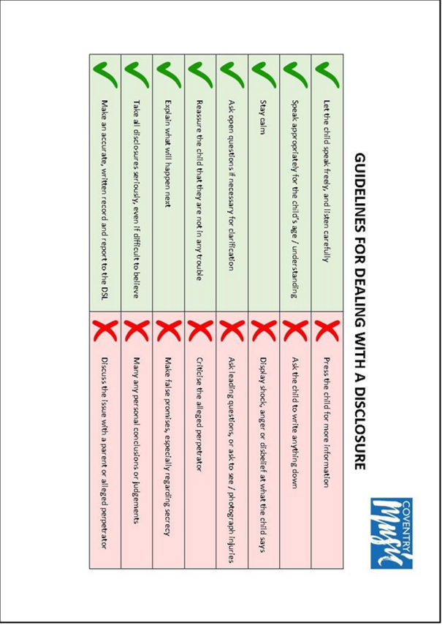

**CAUSE FOR CONCERN FORM**

|  |  |
| --- | --- |
| **Child’s Name** |  |
| **School** |  |
| **School Year** |  |

|  |  |
| --- | --- |
| **Person reporting concern** |  |
| **Position** |  |

|  |  |
| --- | --- |
| **Person completing form** |  |
| **Position** |  |

|  |  |
| --- | --- |
| **Date and time of report** |  |
| **Form of communication** |  |

|  |  |
| --- | --- |
| **Nature of concern** | *Please give full details of the concern, including dates and times* |

|  |  |
| --- | --- |
| **Initial action taken by the person reporting concern** | *This could include details of any conversations with a Class Teacher, School DSL, or Local Authority Social Care Team.* |

|  |  |
| --- | --- |
| **Actions recommended to the person reporting the concern** | *Please include dates when these actions should be completed.* |

|  |  |
| --- | --- |
| **Actions that Coventry Music will take** | *This may include a referral to the Local Authority Social Care Team and/or LADO, or completing an Event Review Form. Please include dates when these actions should be completed.* |

|  |  |
| --- | --- |
| **Signature of person completing form** |  |

**APPENDIX J – INCIDENT REVIEW FORM**

**INCIDENT REVIEW FORM**

|  |  |  |  |
| --- | --- | --- | --- |
| **Reason for Review** | ***Delete as applicable***  **Incident Near-miss Concern Complaint** | | |
| **Person reporting concern** |  | | |
| **Position** |  | | |
| **Date and time of report** |  | **Form of communication** |  |

|  |  |
| --- | --- |
| **Name of activity** |  |
| **Location of activity** |  |
| **Date and time of incident** |  |

|  |  |  |  |  |  |
| --- | --- | --- | --- | --- | --- |
| **Nature of incident** | ***Please give full details of the incident, inluding dates and times*** | | | | |
| **Incident review**  *This may include updating a risk assessment, reviewing the safeguarding policy, change of venue, staff training etc.*  *In case of reported incidents, immediate action must be taken.* | | | | |
| **Action to be taken** | | **Timeframe** | **Staff responsible** | **Outcome** |
|  | |  |  |  |
|  | |  |  |  |
|  | |  |  |  |
|  | |  |  |  |

|  |  |  |
| --- | --- | --- |
| **Signature of DSL** | **Signature of DDSL** | **Signature of Head of Service** |
|  |  |  |